**DAILY ONLINE ACTIVITIES SUMMARY**

|  |  |  |  |  |  |  |  |
| --- | --- | --- | --- | --- | --- | --- | --- |
| **Date:** | **18/05/2020** | | | | **Name:** | **Deena Muthappa** | |
| **Sem & Sec** | **8th sem, A sec** | | | | **USN:** | **4AL16CS028** | |
| **Online Test Summary** | | | | | | | |
| **Subject** | | **SMS** | | | | | |
| **Max. Marks** | | **60** | | **Score** | | **57** | |
| **Certification Course Summary** | | | | | | | |
| **Course** | **Introduction to Ethical Hacking** | | | | | | |
| **Certificate Provider** | | | **Great Learning** | **Duration** | | | **254 mins** |
| **Coding Challenges** | | | | | | | |
| **Problem Statement :** 1 program to print the frequency of each character in a string.  **2** Java program to print even and odd numbers series respectively | | | | | | | |
| **Status: Completed** | | | | | | | |
| **Uploaded the report in Github** | | | | **Yes** | | | |
| **If yes Repository name** | | | | **deenamuthappa/Coding-Challenges** | | | |
| **Uploaded the report in slack** | | | | **Yes** | | | |

Online Test Details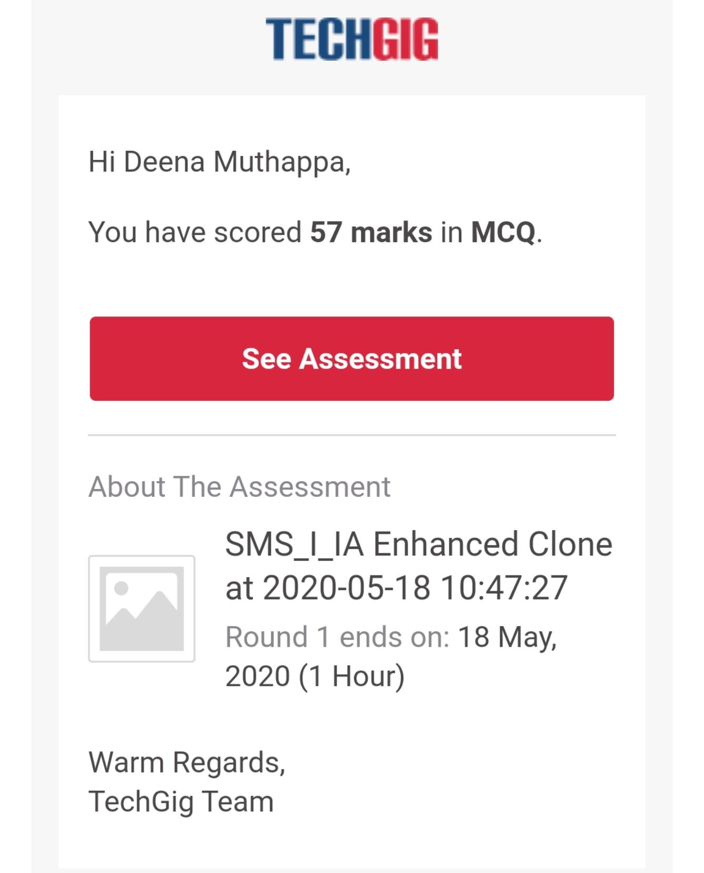

Online examination is conducting a test online to measure the knowledge of the participants on a given topic. With online examination students can do the exam online. The test was on the subject System Modeling and Simulation under the topic Random numbers generation technique.

Certification Course Details:

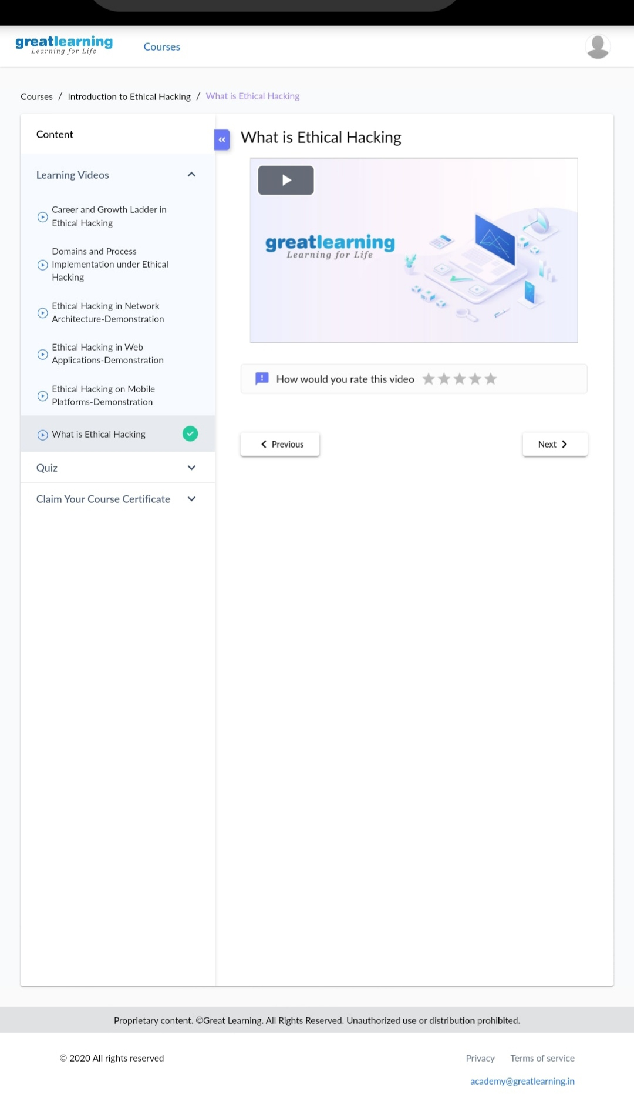

Ethical hacking and ethical hacker are terms used to describe hacking performed by a company or individual to help identify potential threats on a computer or network. An ethical hacker attempts to bypass system security and search for any weak points that could be exploited by malicious hackers.

The primary benefit of ethical hacking is to prevent data from being stolen and misused by malicious attackers.

Coding Challenges Details:

1) Using methods charAt() & length() of String class, write a program to print the

frequency of each character in a string.

“Hello friend”

Output should be

-: 1

d: 1

e: 2

f: 1

(continued for all character in the string)

package pk;

import java.util.Scanner;

public class StringOperators

{

public static void main(String args[])

{

int i;

String str;

int counter[] = new int[256];

Scanner in = new Scanner(System.in);

System.out.print("Enter a String : ");

str=in.nextLine();

for (i = 0; i < str.length(); i++) {

counter[(int) str.charAt(i)]++;

}

// Print Frequency of characters

for (i = 0; i < 256; i++) {

if (counter[i] != 0) {

System.out.println((char) i + ":-" + counter[i] + " times");

}

}

}

}

2) Write down a java program to print even and odd numbers series respectively

from two threads: t1 and t2 synchronizing on a shared object

Let t1 print message “ping — >” and t2 print message “,—-pong”.

Take as command line arguments, the following inputs to the program:

Sleep Interval for thread t1

Write down a java program to print even and odd numbers series respectively from two

threads: t1 and t2 synchronizing on a shared object

Let t1 print message “ping — >” and t2 print message “,—-pong”.

Take as command line arguments, the following inputs to the program:

Sleep Interval for thread t1

Sleep Interval for thread t2

Message per cycle

No of cycles

public class PingPong extends Thread {

static StringBuilder object = new StringBuilder("");

public static void main(String[] args) throws InterruptedException {

Thread t1 = new PingPong();

Thread t2 = new PingPong();

t1.setName("\nping");

t2.setName(" pong");

t1.start();

t2.start();

}

@override

public void run() {

working();

}

void working() {

while (true) {

synchronized (object) {

try {

System.out.print(Thread.currentThread().getName());

object.notify();

object.wait();

} catch (InterruptedException e) {

e.printStackTrace();

}

}

}

}

}